**Web Design & Development 1  
Assignment 2**  
Chloe Ní Mhaolomhar - X00128909  
Dara O’Canaing - X00129954  
Ciara Blair - X00131203

**Part 1a: Site Structure and Navigation**

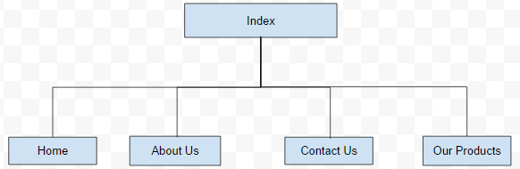

*WebSite Structure*

**Our Plan**

This is how we plan on navigating our website, our goal is to keep the website simple for our users, and easy on the eye ensuring the colours are not too vibrant. The navigating is kept simple because we don’t want the users to get lost trying to find things in our website.

**What the user can do**

The user will be able to view and navigate through the website, they will have access to the Home page, the About Us page, the Contact Us page, and the Our Products page. The pages will display information relative to their names.

**What administrators can do**

Administrators are able to modify the site, they could change the design, navigation, and contents of the site. They will be able to fix bugs, if any, and keep the site running and maintained.

**Page Design**

**Structure & layout**

The structure to the site is simple yet neat, with bright colours that won’t put any strain on the eye, and a simple layout that is easy for the users to use.

**Sketch of the website plan**

**Colour scheme**

We first planned on using dark colours but after trying this out we had difficulty reading the site so we changed the colours. We then decided to use pastel colours to make the site easier to read and it was also less of a strain on our eyes looking at it.

**Pictures we used**

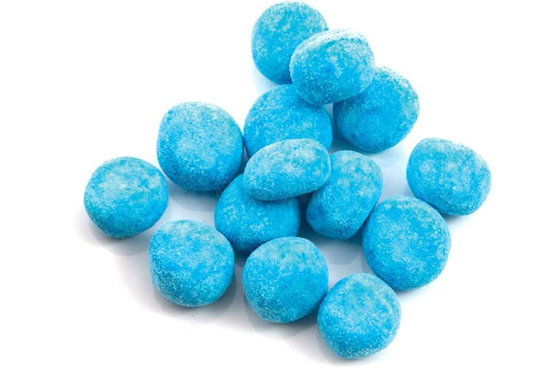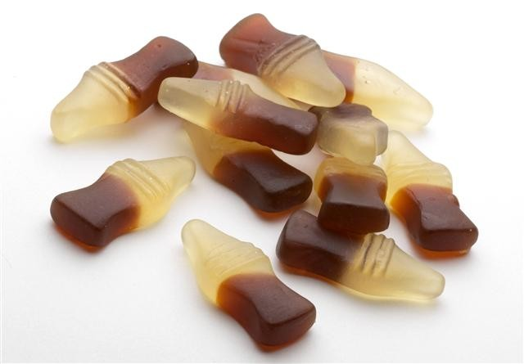 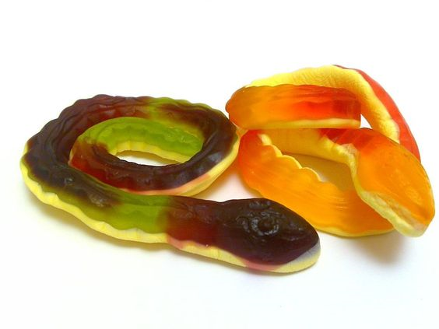  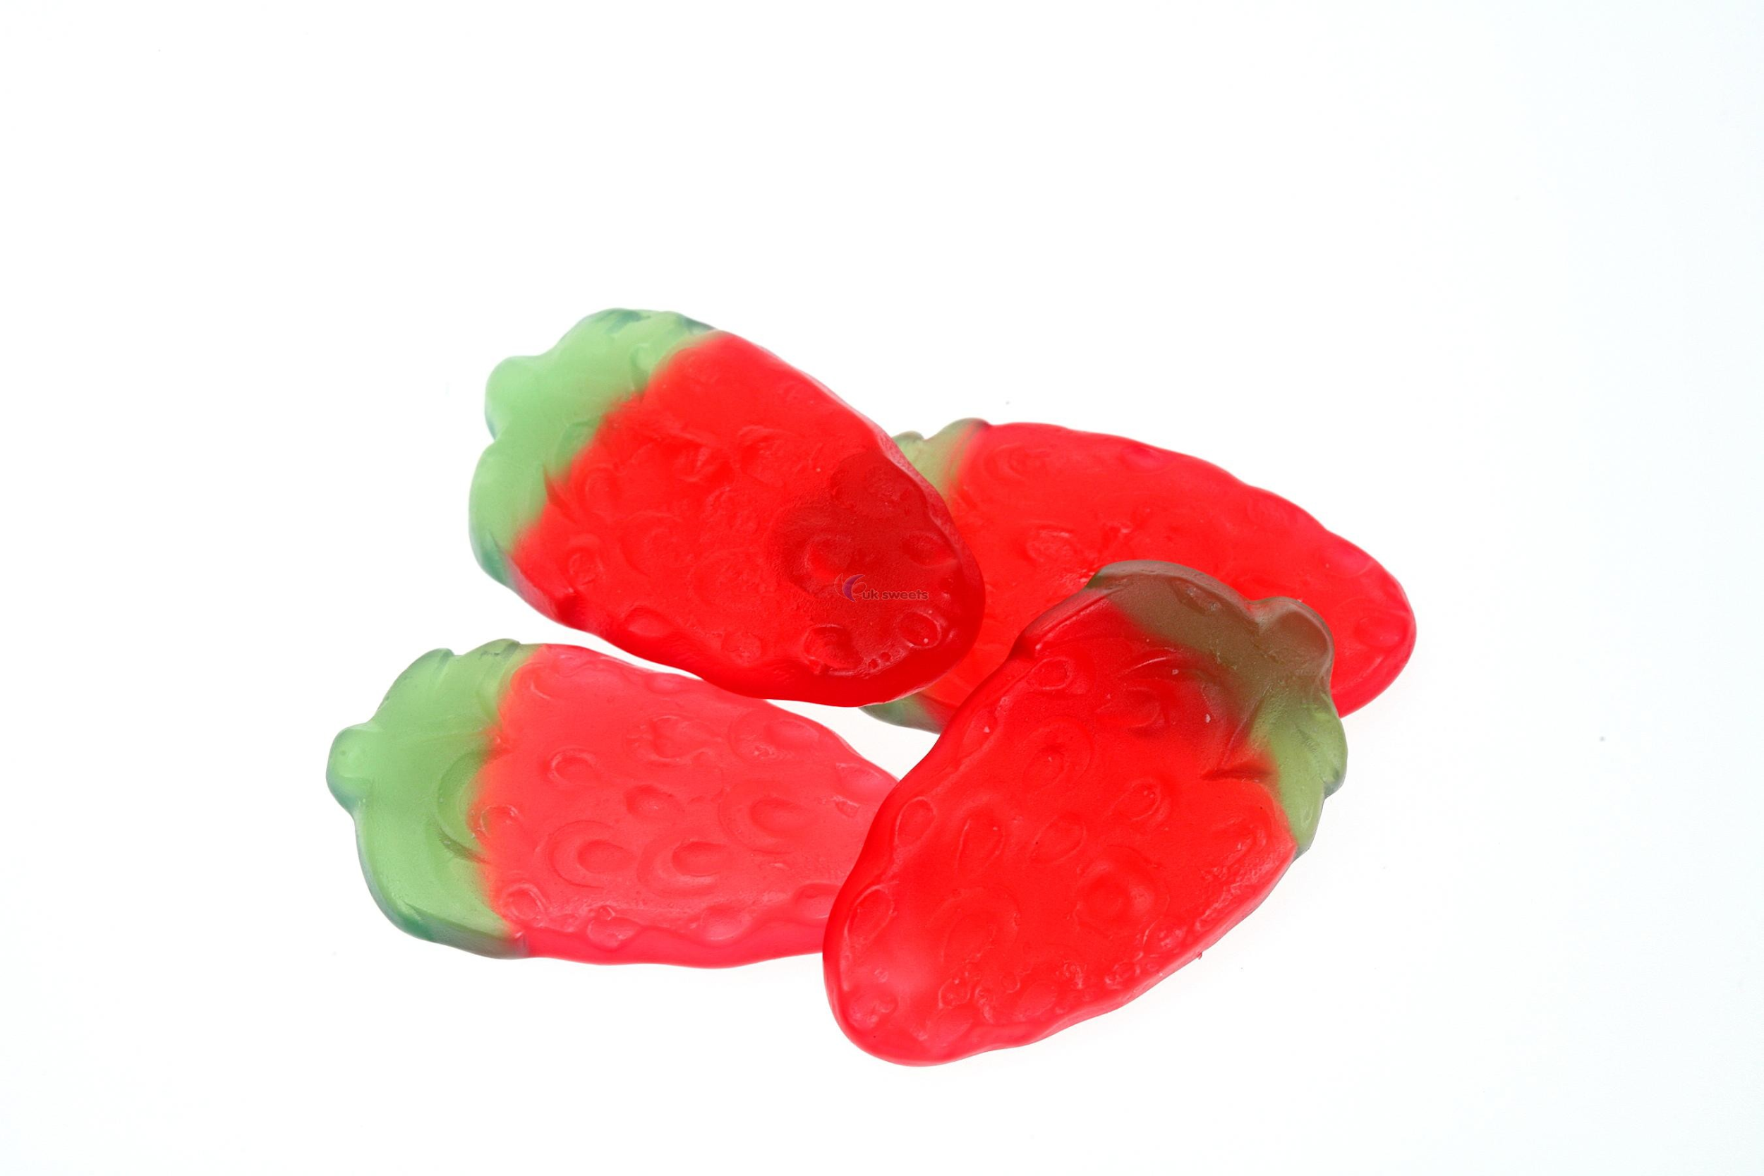 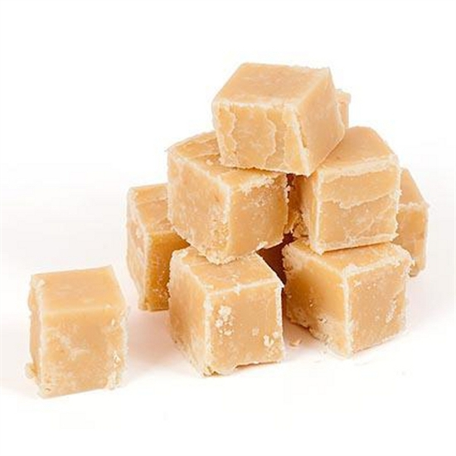

**Part 1b: Prototype in HTML & CSS**

**How the site was coded**

We coded our website using HTML5 and CSS. We also used the Twitter bootstrap layout. We used various techniques for forms, buttons and the general design. We started by dividing our page into navigation, content and footer. This made it easier to design and organise our website. Similarly for design purposes we used classes and ID’s so that when it came to the css we could design the website easily.

**Contribution by each Team member.**

Each team member worked on every part of the project and contributed evenly. The whole project was done when we met as a group rather than people doing it separately.